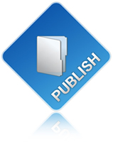

Engage: Publish
Module User’s Guide

Version 4.0

Introduction 3
Installation 3
Installation Process 3
Upgrade Process 3
Uninstalling Engage Publish 3
Common Terms 3
Common Item Fields 4
Module Setup 6
Manage Content 7
Category Administration 7
Category Attributes 7
Article Administration 8
Article Attributes 8
Types of Displays 8
Article Display 9
Category Display 10
Category Search 11
Category Feature Display 13
Item Listing 13
Workflow – Control Publishing of Content 15
Support 16

Introduction
Engage: Publish (formerly AMS or Article Management System) is an enterprise-class content management module for DotNetNuke (DNN). It provides content authoring, editing and approval workflow. Multiple levels of categorization of content provides an un-matched level of flexibility and organization of your content. This 4.0 module is built for DNN 4.x (ASP.Net 2.0).

Installation

Installation Process
Installation for the Engage Publish Module is consistent with all PA installs for DotNetNuke modules. Use the standard Upload New Module menu from the Module Definitions page under the Host Menu to install the module.

Upgrade Process
The upgrade process for the Engage Publish Module mimics the installation process, the upgrade process will run only the necessary upgrade scripts based on the Version of the Engage Publish Module you have installed, and the version you are installing.

Uninstalling Engage Publish
Uninstalling Engage Publish Module is consistent with all PA installs for DotNetNuke modules. Use the standard options on the Module Definitions page under the Host Menu to install the module.
Note: The uninstall process leaves the following empty folders in DesktopModules\EngagePublish:
Admin, ArticleControls, CategoryControls, Controls. You can safely delete these folders after performing the uninstall.

Common Terms
Item- An item is the generic type in the new Engage Publish system. Examples of items are Articles and Categories.

Article- An article is a piece of writing on a specific topic, by one or more authors, that forms an independent part of a periodical publication such as a journal or serial, magazine, newspaper, or website.

Category- A classification or grouping under which articles are organized.

ItemLink.aspx?itemid=###- the method for linking to items in the Engage Publish system. This page is used to link to modules both internal to Engage Publish as well as users that want to link from other sites.
Example:
http://www.engagesoftware.net/desktopmodules/engagepublish/itemlink.aspx?itemid=###

Workflow – This term describes how content approval can be controlled within Engage Publish.

Common Item Fields
Item Id- The ID of the item you are editing.

Sort Order- For items that may be sorted in an order other than alphabetical, you can input a numerical sort order. The lower the number the higher in the order it will show up.

Name- The name (or title) of an item.

Description- Item description (or abstract) -- the text that will display on any abstract listings.
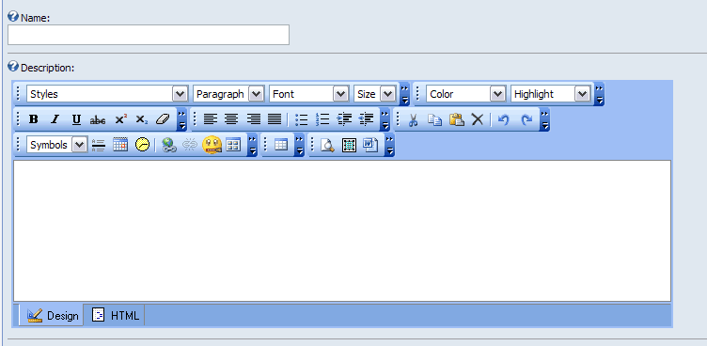

Start Date- Start date for an item; the item will not be displayed on the site until after the start date.  End Date- End date for an item; the item will not be displayed on the site after the end date. Can be left blank and item will always display.  Meta Keywords- Search engine keywords; used for the META keyword tag in an HTML page to help with search indexing.  Meta Description- Search engine description; used for the META description tag in an HTML page to help with search indexing.  Browser Title- Text to display as the browser title. For optimal search engine indexing, this should include words from the meta keywords and the article body. If you have friendly URLs turned on in DNN, the meta title is inserted as the filename in the URL for the page.  Disabled- A disabled item will display in lists, but will not link to any content. A disabled item could be used for a category that you want to create but don’t want to link to.  Thumbnail Image- An image to display as an item’s thumbnail. Upload a new image or select an existing image. | 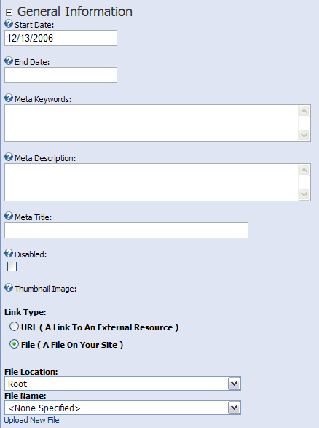
Choosing A Parent Category- Choose a parent category for your item. You can only choose one parent category. For most items, you must choose a parent category; the exception is when creating a category. Categories do not have to have a parent. Other items must fall within a parent category in order to be able to locate those items in the Engage Publish system.

Choosing Related Categories- Choose related categories for your item. You can choose multiple related categories. Related categories are optional.

Display Page- The page on which the item will be displayed. This list is populated with the pages that have an Engage Publish module. Each item must have a display page. This controls which items are displayed on which pages, allowing you to display specific items on pages that have skins to match that item. The “child display page” setting from a parent category is inherited by its children items. If you want to override the page in which an item should display, you would change the item’s setting. The number in parenthesis () is the DotNetNuke TabId of a particular page.
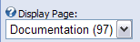

Approval Status- Approval status allows an author to control the workflow for an item.  Administrators have the ability to immediately approve an item. An approved item will display immediately on the website. The other approval states include Edit, Waiting for Approval and Archived.  If email notification is enabled in the Engage Publish Administration Setup, authors get the option to “Submit For Approval.” This sends an email to the administrator(s), notifying them that an item is waiting for approval. | Administrator:  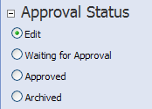  Author:  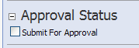

Module Setup
This process must be completed prior to managing Engage: Publish content. The first time you add the Engage Publish module to a page you are presented with instructions indicating that you need to create Categories and Articles.

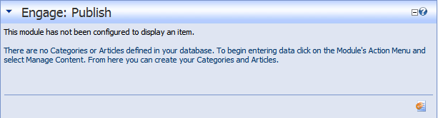

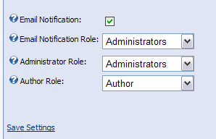
From this settings page you can:
- Turn on “Email Notifications” for the item approval workflow process.
- Email Notification Role, this allows you to setup a specific role to be notified when there are items waiting for approval. Perhaps you want only a few of those in the admin role to receive email notification.
- Define the Administrator Role, the role that will be able to approve items.
- Define the Authors Role, the role that can create content but not approve content. (See Workflow section)

Manage Content
The Manage Content Menu provides you with entry point into the item edit screens for the various items in Engage Publish.
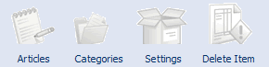

Category Administration
Before you can add articles, you must first create at least one category. Categories are the grouping mechanism for all items. To add a category, go to Manage Content option on the module’s action menu. Click on the categories icon, and then choose Add Category.

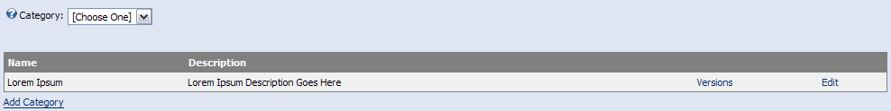

Category Attributes
Common Fields – Please refer to the common item fields section of this document.

Featured Articles- Featured articles are used by the Category Feature display type. To add a featured article to a category, search for article by title or id. Once you search, the results will appear in the Available list below the search box.

When you add an item to the Selected list, you can then sort the list; this controls the sort order on the Category Feature display type. You can also click on an item in the Selected list and define start and end dates, allowing you to define when an article is displayed in a Category Feature display type. You must click “Save Dates” for each featured article you add BEFORE you click on the Update to save the Category. If you fail to do this the dates will not be added to the relationship.

Child Display Page- This is a category specific setting, allowing you to specify the default display page for children of this category. You can override this for each child item.

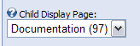

Article Administration
Before you can add articles, you must select a Category. To add an article, click the Add Article link.
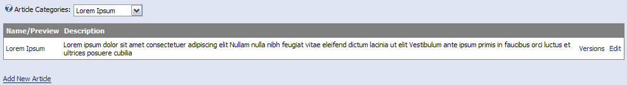

Article Attributes
Common Fields – Please refer to the common item fields section of this document.

Related Articles- Links to related articles are displayed in the related articles section of the Article display. You have the ability to “search” for related articles.

Embedded Article- This article will be embedded in the upper right corner of article display pages. You can only choose one article in this selection area.

Version Number- The version number of an article. This is an optional field.

Version Description- Text area for an article author to describe any changes between versions of an article. This is an optional field.

Article Text- The main content of an article.

Types of Displays
The Engage Publish Module can display content in five ways. Once you have added the module to a page and have added content (Categories and Articles) navigate to the settings using the standard DNN Settings action menu to select the desired display type.

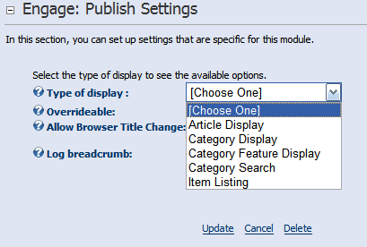

After selecting the display type you will be presented with a set of options for each type i.e. Article Display you would need to select the article that the module should display.
When putting this control on a page you can choose from the following options. These three options are standard for Display Types that you choose.

- Overrideable- Check to allow this control to be overridden from a value in the querystring. This is used in cases where you already have a module defined that is configured to display an article but you want to change the item via the querystring you can.
- Allow browser title change- This allows you to define if this control will change the browser title or not. If you have an Engage Publish Module on a page multiple times you only want to enable this on one of those instances, otherwise the last Engage Publish Module to load will set the page title, and that may not be the results you intend.
- Log Breadcrumb – this is only used if you’re using the Engage Publish Breadcrumb skin object.

Article Display
The Article Display option is used for the scenario when you want to display your article in a module.

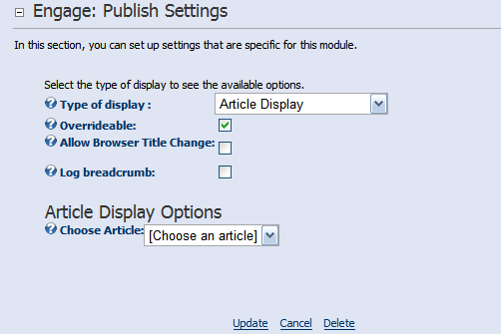

Category Display
This Display Type is desired when you have a Category defined and you wish to display Articles belonging to that Category or Categories related to other Categories.
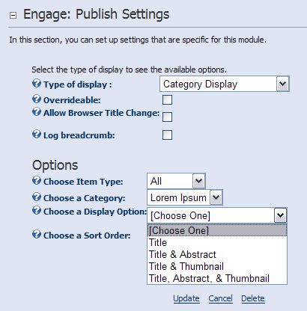

Options:
- Choose an Item Type – Select either Article or Category
- Choose the Category – This is either a Category of Articles or the “Parent” Category based on the Item Type you have selected.
- Choose a Display Option – This option controls how the items are displayed. There are four options to choose from.
  - Title – Displays the Title only.
  - Title & Abstract – Displays the Title and Abstract.
  - Title & Thumbnail – Displays the Title and Thumbnail.
  - Title, Abstract, & Thumbnail – Displays the Title, Abstract and Thumbnail.
- Choose Sort Order – This field is provided to change the sort order for how you want to display the items in a category. By default items are displayed by name ascending.

Category Search
The Category Search Display Type allows you to search through articles within a given category. You
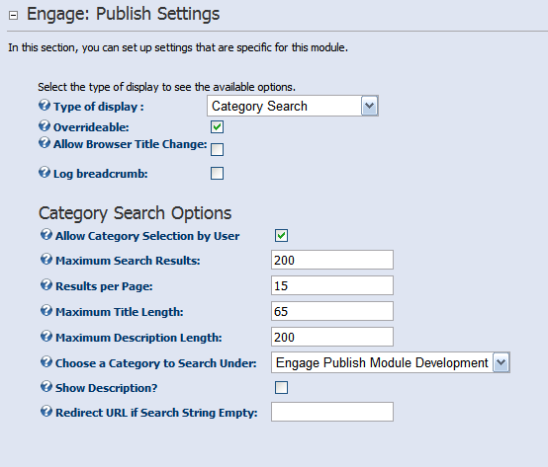

Options:
- Allow Category Selection by User – This option enables/disables the user from changing the category in which they are searching.
- Maximum Search Results – This controls the number for results returned.
- Results per Page – The number of items displayed per page.
- Maximum Title Length – In cases where titles become very long you will want to control the number of characters to prevent the module width from interfering with your site design.
- Maximum Description Length - Same as number four but related to the description of the item.
- Choose a Category to Search Under – Select the category to search in. If Allow Category Selection By User is unchecked then the user can select different categories to search.
- Show Description - You can turn off the description all together if desired in the search results.
- Redirect URL is Search String is Empty – This option can be used in cases where you would want to redirect the user to another page or site entirely if no criteria is specified. An example of this is when you have an Engage Publish module already configured to display all Articles.

Category Feature Display
This Display Type is used to display featured Articles defined as such while creating Categories. An option while editing your Category is to add featured Articles. Using this Display Type you can display only those articles.
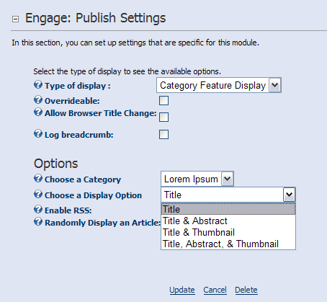

Options:
- Choose a Category – Select a Category that contains featured Articles.
- Choose a Display Option – This option controls how the items are displayed. There are four options to choose from.
  - Title – Displays the Title only.
  - Title & Abstract – Displays the Title and Abstract.
  - Title & Thumbnail – Displays the Title and Thumbnail.
  - Title, Abstract, & Thumbnail – Displays the Title, Abstract and Thumbnail.
- Enable RSS – When this option is enabled the module displays the standard RSS icon to allow syndication.
- Randomly Display an Article – In cases where you want to display only a single featured Article select this option. One Article is displayed randomly each time the page/module is loaded.

Item Listing
The Item listing Display Type allows you to display a listing of items in a particular category and particular item type on the page with a limit to the number of items displayed. You can also change the settings to display the most popular items of a category, and the most recent items of a category.
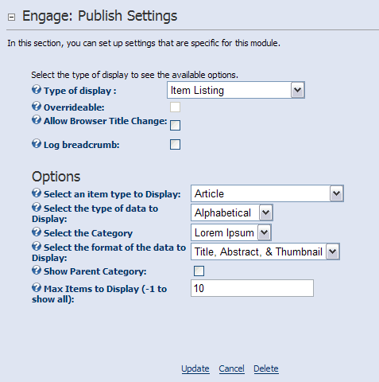

- Select an item type to Display – Select either Article or Category
- Select the type of data to Display – There are three options to control what type of data is displayed.
  - Alphabetical
  - Most Popular
  - Most Recent
- Choose a Display Option – This option controls how the items are displayed. There are four options to choose from.
- Title – Displays the Title only.
- Title & Abstract – Displays the Title and Abstract.
- Title & Thumbnail – Displays the Title and Thumbnail.
- Title, Abstract, & Thumbnail – Displays the Title, Abstract and Thumbnail.
- Max Items to Display - This option allows you to control the number of items displayed.
- Enable RSS – When this option is enabled the module displays the standard RSS icon to allow syndication.

Workflow – Control Publishing of Content
Engage Publish includes a feature to help control content creation and approval.

If you wish to use this feature, it is recommended to create a new role called “Authors” and add the appropriate users to this role (individuals who would be allowed create content but not approve or publish it). When content is approved it becomes “live” on the site immediately. The workflow feature allows for an approval process to occur by the users that belong to the Content Approvers role.

If you wish to further segment users into a specific role for approving content, create a new role called “Content Approvers” and add the individuals responsible for approving content to this role.

Once you have defined the two roles and related users navigate to the Settings area by selecting the Manage Content from the action menu on the module and select the appropriate roles to be used. (e.g. Authors Role: Authors and Content Approvers: Content Approvers)
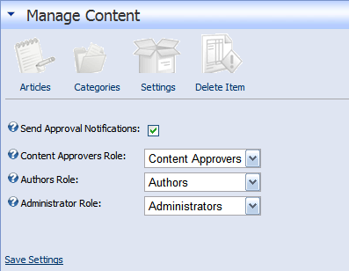

Small organizations may not want to send emails each time content is changed. For larger implementations, users in the Content Approvers role can be notified about changes via email. When content is changed by an Author, Approvers receive an email containing a link to the changed content. This allows an approver to login to the site and review the content and either approve, decline or further modify the content and approve. To enable email notifications, check the Send Approval Notifications checkbox. NOTE: Email notifications use the same mechanism as DotNetNuke, so it is important to verify SMTP mail is configured correctly under the Host Settings menu.

The Administrator Role setting allows you to specify the role in which users can add/edit and approve content in real-time. Changes made to content by these users are display immediately on the site.

Authors
Authors making changes to content will notice a check box at the bottom of the page called Submit for Approval. When checked, this item will be put into a Waiting for Approval status and (if configured to do so) Approvers will receive an email about the change.
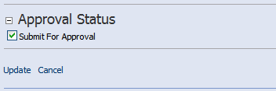

Approvers
The email that is sent to the Approver(s) will contain a subject line about what kind of content is waiting approval. i.e. Article or a Category waiting for approval.

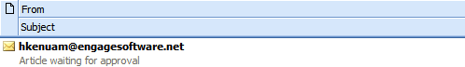

The email body will contain a link to the item that has changed including the title of the content.
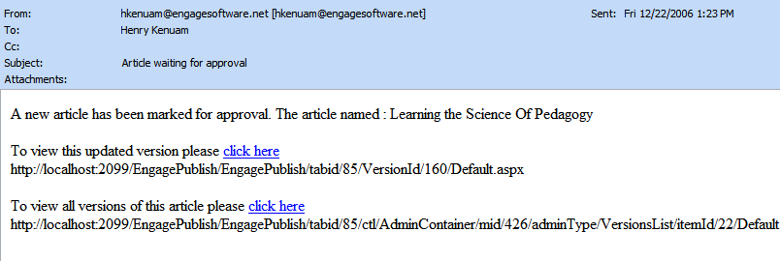
Also included is a URL to all the versions of the item that has changed.

Note: The complete URL has been provided so that you may copy and paste into a browser that is already open to the site.

The workflow functionality of Engage Publish allows you to “stay in touch” with any and all changes to content preventing any unwanted material from displaying on your site.

Requirements
ASP.NET Ajax 1.0

To utilize the modal popup for Publish Comments please be sure to define your Doctype in your DNN Skins. This has been tested with the following doctype.

<!DOCTYPE html PUBLIC "-//W3C//DTD XHTML 1.0 Transitional//EN" "http://www.w3.org/TR/xhtml1/DTD/xhtml1-transitional.dtd">

In the <DotNetNukeRoot>/Default.aspx file, please add

<asp:ScriptManager ID="sc1" runat="server" />

On the line after the FORM tag.

Support
Please visit www.engagemodules.com for product support forums or email us at support@engagemodules.com.

